FORNAX™ ePlanCheck Rule
Rule Information
Rule ID | SWD 9.9
Rule Name | Safety Railings for Open Drains
Chapter | Part I Planning Requirements
Section | 4 Drainage Planning Requirements
Handbook | Code of Practice on Surface Water Drainage  Seventh Edition – Dec 2018

Rule Description
9.9 Safety Railings

Standard safety railings shall be provided for all open drains more than 1.0 m deep. “Type B” railings as specified in Land Transport Authority’s latest Standard Details of Road Elements shall be installed for new open drains. Otherwise, railings as specified in Drawing No.6, to match the existing railings on site, shall be installed when requested by the Board.

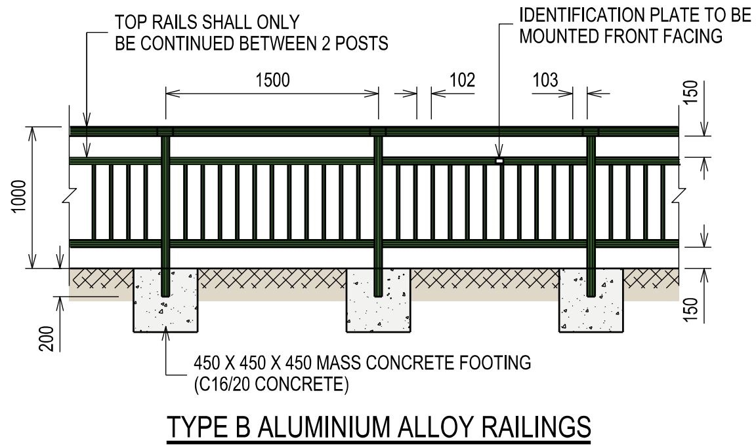

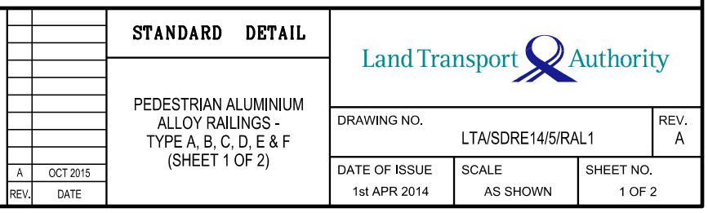

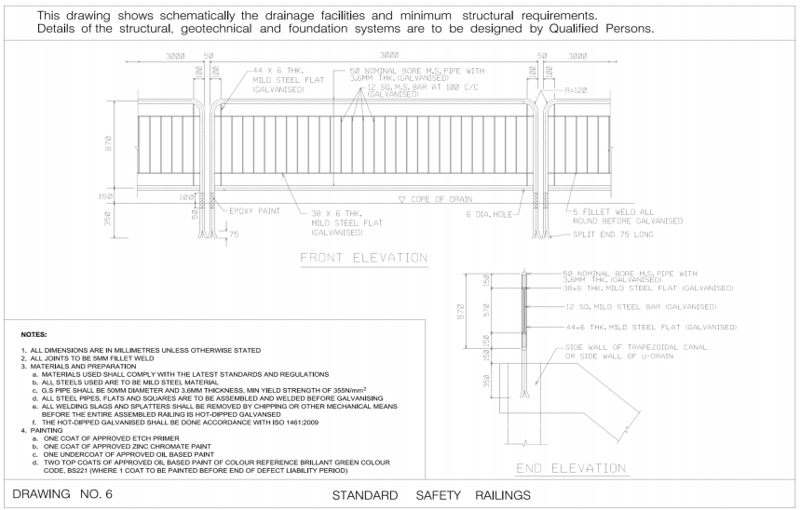

Rule Interpretation
- This rule checks for the provision of standard safety railings for all open drains more than 1000 mm deep.
- For all new open drains use the following standard safety design of railings.
- “Type B” as specified in Land Transport Authority’s latest Standard Details of Road Elements. (Figure 01)
- Or Drawing No.6, to match the existing railings on site, as requested by the Board.(Figure 02)

TYPE B SAFETY RAILING
1000 mm

MINIMUM DEPTH

Type B Safety Railing Elevation View
FIGURE 01

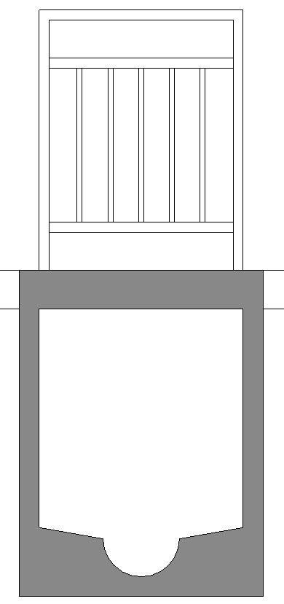

1000 mm

MINIMUM DEPTH

CLOSE DRAIN
TYPE B SAFETY RAILING

MINIMUM DEPTH

1200 mm

OPEN “U” DRAIN

Type B Safety Railing Section View
FIGURE 01

DRAWING 06 SAFETY RAILING

1000 mm

MINIMUM DEPTH

Drawing 06 Safety Railing Elevation View
FIGURE 02

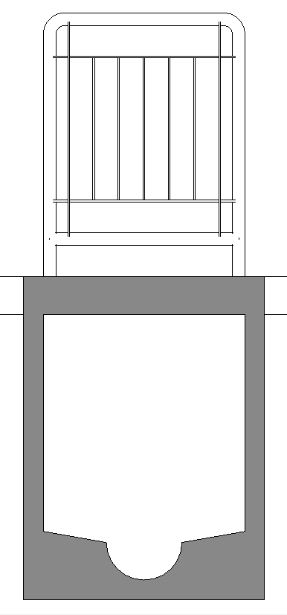

1000 mm

MINIMUM DEPTH

CLOSE DRAIN
TYPE B SAFETY RAILING

MINIMUM DEPTH

1200 mm

OPEN “U” DRAIN

Standard Safety Railing (Drawing No. 6) Section View
FIGURE 02

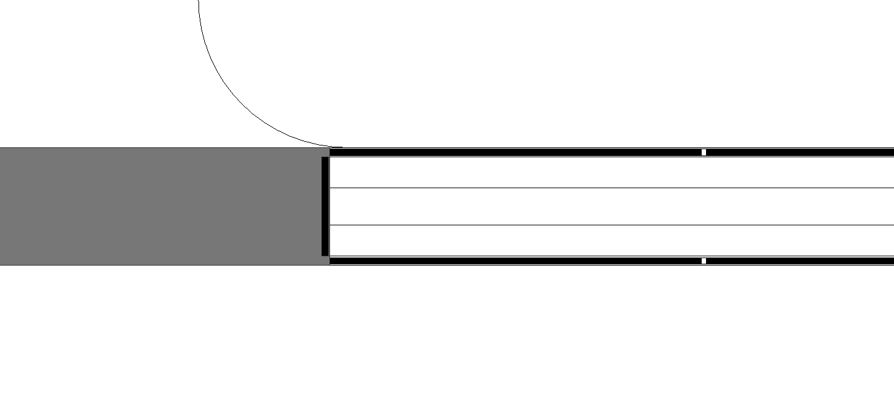
CLOSED DRAIN
OPEN “U” DRAIN
RAILING

Plan View
FIGURE 03

Rule Scenario

Scenario 01 – Compliant 01
Requirement | Provision of standard safety railings for all open drains.
Description | New Open U Drain is 1200mm Depth with Type B Standard Safety Railing.
OPEN “U” DRAIN
TYPE B SAFETY RAILING
1200 mm

SECTION VIEW
FIGURE SCENARIO

Scenario 01 – Compliant 02
Requirement | Provision of standard safety railings for all open drains.
Description | New Close Drain is 1200mm Depth with Type B Standard Safety Railing.
TYPE B SAFETY RAILING

1200 mm

CLOSE DRAIN

SECTION VIEW
FIGURE SCENARIO

Scenario 01 – Non-Compliant 01
Requirement | Provision of standard safety railings for all open drains.
Description | New Open U Drain is 1200mm Depth without Type B Standard Safety Railing.
NO TYPE B SAFETY RAILING INSTALLED

1200 mm

OPEN “U” DRAIN

SECTION VIEW
FIGURE SCENARIO

Scenario 02 – Compliant 01
Requirement | Provision of standard safety railings for all open drains.
Description | New Open U Drain is 1200mm Depth with Drawing 06 Standard Safety Railing.
OPEN “U” DRAIN
DRAWING 06 SAFETY RAILING
1200 mm

FIGURE SCENARIO
SECTION VIEW

Scenario 02 – Compliant 02
Requirement | Provision of standard safety railings for all open drains.
Description | New Close Drain is 1200mm Depth with Drawing 06 Standard Safety Railing.
DRAWING 06 SAFETY RAILING

1200 mm

CLOSE DRAIN

FIGURE SCENARIO
SECTION VIEW

Scenario 02 – Non-Compliant
Requirement | Provision of standard safety railings for all open drains.
Description | New Open U Drain is 1200mm Depth without Drawing 06 Standard Safety Railing.
NO DRAWING 06 SAFETY RAILING INSTALLED

1200 mm

OPEN “U” DRAIN

FIGURE SCENARIO
SECTION VIEW

Model PreCheck

Required Elements | Required Attributes
PipeSegment | ObjectType contains “Open U Drain”
Railing | ObjectType contains “Type B Railing”
Railing | ObjectType contains “Drawing 06 Railing”

Rule Parameters

Element Type 1
State | Type | Property | Operator | Value
Include | Railing | ObjectType | Contains | Type B Railings
Include | Railing | ObjectType | Contains | Drawing 06 Railings
 |  |  | N.A. | <User defined>

Element Type 2
State | Type | Property | Operator | Value
Include | PipeSegment | ObjectType | Contains | Open U Drain
Include | PipeSegment | ObjectType | Contains | Close Drain

Element Type 1 Condition
Shall be provided along the top both sides of Element Type 2

Element Type 2 Condition
Minimum Depth = | 1000 | mm

Result Messages
9.9 Provision of Standard Safety Railings for all Open Drains
  - Non-Compliant (TotalResultNumeric)
    - SpaceTypeNameNumeric (TotalResultPerFloorNumeric)
    - SpaceType1Value
    - No Standard Safety Railing Type B is provided on top of the Open U Drain. (As per Land Transport Authority’s latest Standard Details of Road Elements)
    - Height mm of Open U Drain.

    - SpaceType1Value
    - No Standard Safety Railing Drawing 06 is provided on top of the Open U Drain.
    - Height mm of Open U Drain.

  - Compliant (TotalResultNumeric)
    - SpaceTypeNameNumeric(TotalResultPerFloorNumeric)
    - SpaceType1Value
    - Standard Safety Railing Type B is provided on top of the Open U Drain. (As per Land Transport Authority’s latest Standard Details of Road Elements)
    - Height mm of Open U Drain.
    - SpaceType1Value
    - Standard Safety Railing Drawing 06 is provided on top of the Open U Drain.
    - Height mm of Open U Drain.

  - Attention (TotalResultNumeric)
    - SpaceTypeNameNumeric(TotalResultPerFloorNumeric)
    - Depth of Open U Drain is less than 1000 mm

Sample Result Messages
9.9 Provision of standard safety railings for all open drains.

  - Non-compliant (2)
    - Road Level
    - No ElementType1 Value is provided on top of the ElementType2 Value. (As per Land Transport Authority’s latest Standard Details of Road Elements)
    - No ElementType1 Value is provided on top of the ElementType2 Value .(Drawing 06, As per Request of Board)
1200 mm

  - Compliant (1)
    - Road Level
    - ElementType1 Value is provided on top of the ElementType2 Value. (As per Land Transport Authority’s latest Standard Details of Road Elements)
    - ElementType1 Value is provided on top of the ElementType2 Value .(Drawing 06, As per Request of Board)
1200 mm

1200 mm

  - Attention (1)
    - Road Level
    - Depth of Open U Drain is less than 1000 mm

Sample Result Model Views
9.9 Provision of standard safety railings for all open drains.
  - Non-compliant
    - Sectional elevation view.
    - Highlight checked elements.
    - All other elements are translucent except for the checked elements.
  - Compliant
    - Sectional elevation view.
    - Highlight checked elements.
    - All other elements are translucent except for the checked elements.

Testing Scenario Notes
- Scenario 01-Non-Compliant
    - Road Level
    - No Standard Safety Railing Type B found on top of the Open U Drain. (As per Land Transport Authority’s latest Standard Details of Road Elements)

- Scenario 02-Non-Compliant
    - Road Level
    - No Standard Safety Railing Drawing 06 found on top of the Open U Drain.

- Scenario 01-Compliant
    - Road Level
    - Standard Safety Railing Type B found on top of the Open U Drain. (As per Land Transport Authority’s latest Standard Details of Road Elements)

- Scenario 02-Compliant
    - Road Level
    - Standard Safety Railing Drawing 06 found on top of the Open U Drain.

Model:
SWD 9.9 Scenario 01 Non-Compliant.ifc
SWD 9.9 Scenario 02 Non-Compliant.ifc
SWD 9.9 Scenario 01 Compliant.ifc
SWD 9.9 Scenario 02 Compliant.ifc

Modeling Guideline
- Specify IfcObjectType containing “Open U Drain” for relevant PipeSegment.
- Specify IfcRailing containing “Railing”.

Specification Log
RA | Jomhar Labao
Last edit date | 23 November 2018
ePC version
Updates | - V1

Specification Log
RA | Karl Michael Bautista
Last edit date | 20 December 2018
ePC version | V1
Updates | - Updated RI and UAT Revit as per PUB comments

